Computer Interfacing and Peripheral Equipment
Laboratory Exercise 16
Rick L. Swenson

Description: Interfacing the DLP-IO8 from www.dlpdesign.com with LabWindowsCVI

Material:
DLP-IO8
PC with LabWindowsCVI

The DLP-I08

INTRODUCTION
The DLP-IO8 Data Acquisition Module is a low-cost, easy-to-use data acquisition system for measuring voltages, controlling and monitoring processes, and acquiring temperature data. Each of the 8 available channels can be configured for any of the digital, analog, or temperature modes via single-byte commands. All operational power is taken from the host PC via the USB port.

The mode of each I/O is automatically changed with each command sent. For example, if an I/O is set to Digital Output – High and then the Digital Input Mode is selected, the I/O is first changed to Input Mode and then the high/low state is read and returned to the host.

FEATURES:
- 8 Channels: Digital I/O, Analog In, Temperature
- USB Port Powered
- USB 1.1 and 2.0 Compatible Interface
- Small Footprint; Easily Fits on Desktop
- Easy to Use with Single-Byte Commands
- Can Utilize a Simple Terminal Emulator to Control All Functions

SPECIFICATIONS:
The DLP-IO8 is a 5-volt system that derives its power from the host USB port. Each channel has the following capabilities:
- Digital Output: Set high, or clear to low. (The actual high/low voltage depends upon sink/source current.)
- Digital Input: Read the high/low state.
- Analog In: Read and return the voltage on each I/O pin using a 10-bit A/D: 0-5 volt range.
- Temperature: Measure temperature using a digital temperature sensor (purchased separately) in the range of 67 to 257°F (-55 to 125°C).

ABSOLUTE MAXIMUM RATINGS:
Stresses above those listed here may cause permanent damage to the DLP-IO8:
- Operating Temperature: 0-70°C
- Voltage on I/Os with Respect to Ground: -0.3V to +5.3V
- Sink/Source Current on Any I/O: 25mA

WARNINGS
- Unplug from the host PC before connecting to the DLP-IO8.
- Isolate the bottom of the board from all conductive surfaces.
- Observe static precautions to prevent damage to the DLP-IO8 module.

USB DRIVERS
USB drivers for the following operating systems are available for download from the DLP Design website:
Windows XP x64, Mac OSX
Windows Server 2003, Mac OS9
Windows 2000, Mac OS8
Windows 98, ME, Linux

These drivers are available for download from the following page: http://www.dlpdesign.com/DNLD8/.

USING THE DLP-IO8
Simply connect the DLP-IO8 to the PC to initiate the loading of drivers. Once the drivers are loaded, the DLP-IO8 is ready for use. All commands are single-byte commands.
You can either utilize a simple terminal emulator program, or write your own program in your language of choice. Begin by opening the COM port, set the baud rate to 115200, and send single-byte commands as shown in Table 1. The Ping command can be used to locate the correct COM port used for communicating with the DLP-IO8, or you can look in Device Manager to see which port was assigned by Windows.

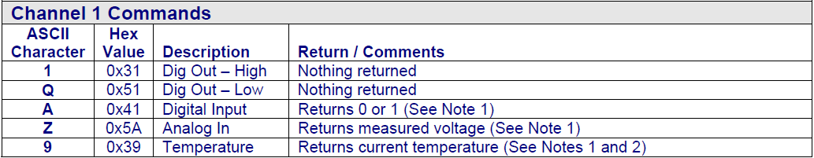

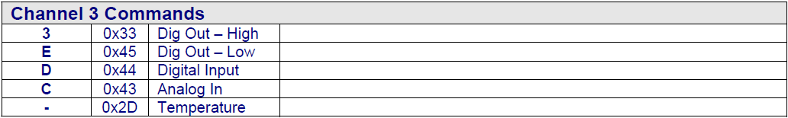

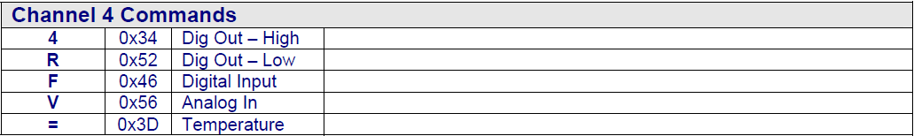

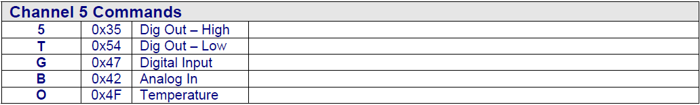

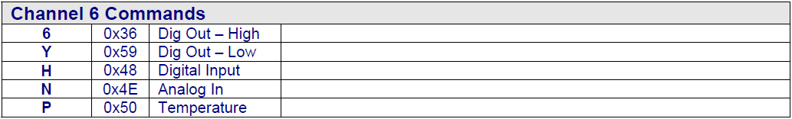

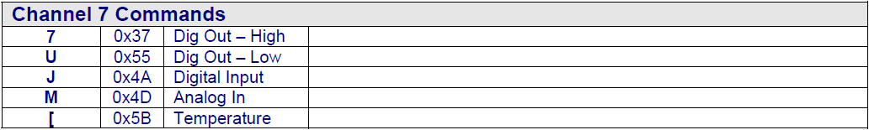

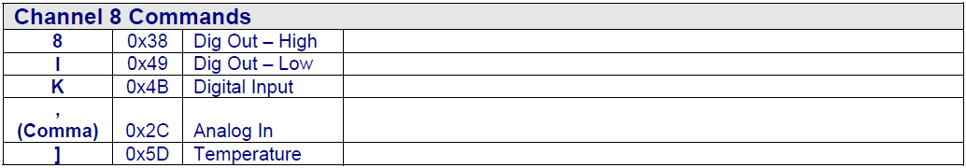

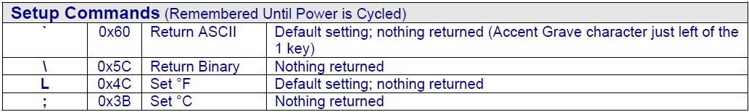

Note 1 – Data is returned in either the form of ASCII characters (ex: 1.25V, 78.2°F) or binary (raw data) depending upon the current mode. The power-up default mode is ASCII mode such that data is easily read using a terminal emulator program.
Note 2 – Requires DS18B20 digital

Objective:
Write a LabWindows CVI program that interfaces as shown in the Figure below:

